|  |  |  |  |  |  |
| --- | --- | --- | --- | --- | --- |
| Date | 25-Nov-22 | | | Tester Name | Andrew McLaughlin |
| Environment | Penfax - Test | | | Login used |  |
| Operating System | Select OS | Version: | Update: | | |
| Software Used | Select Software | Version: | Update: | | |
| Select Software | Version: | Update: | | |
| Release version | 22.4.1 | | | | |
| Title | Death – Single pensioner GP Expired | | | | |
| Test Type | Regression | | | | |
| Test Scenario | Death – Single pensioner GP Expired | | | | |
|  |  | | | | |
| Expected Results | When a single pensioner passes away and the GP is expired, there should be no benefit payable to anyone and their income benefit should end on the last day of the month they pass away. | | | | |
| Pass/Fail | Pass | | | JIRA# | N/A |

Describe your steps with screenshots:

Member is on Single Life with an expired GP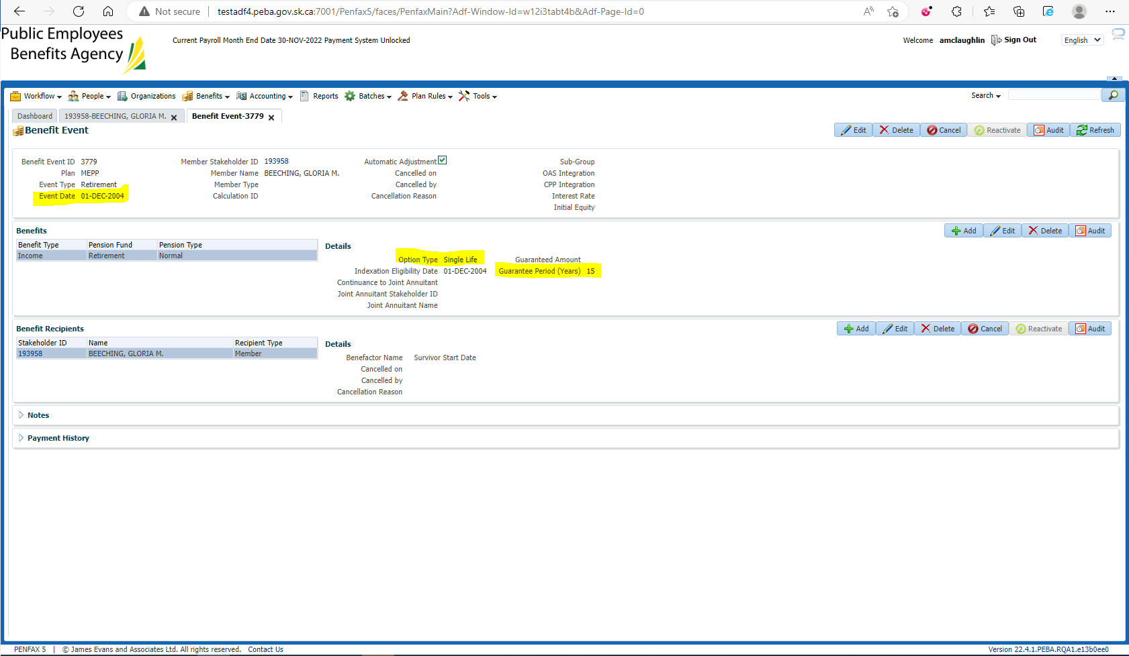

Member has a beneficiary 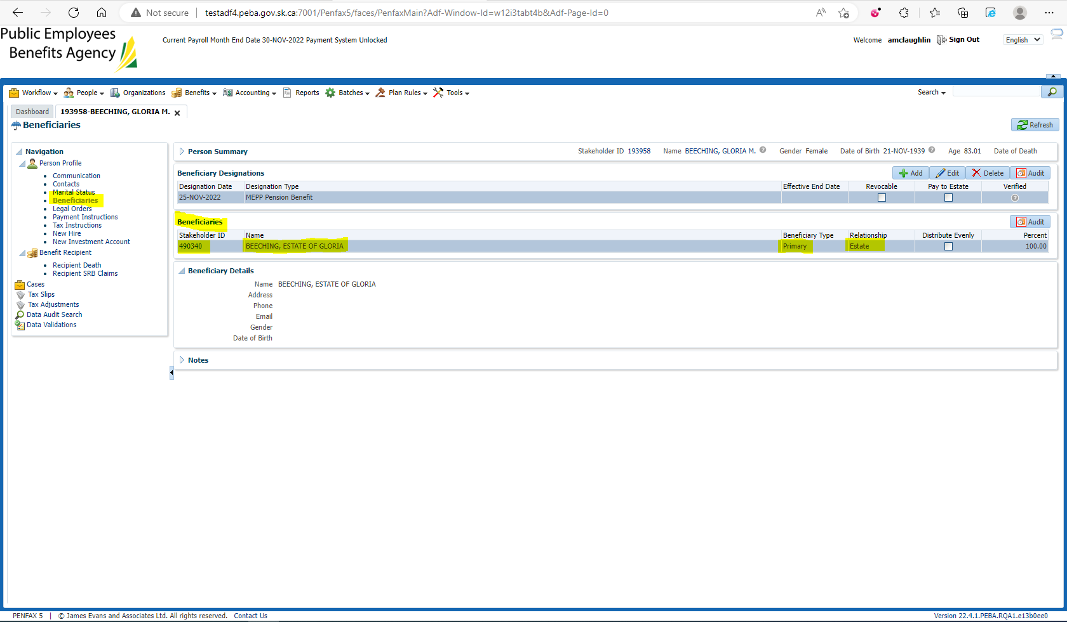

Enter Death Date 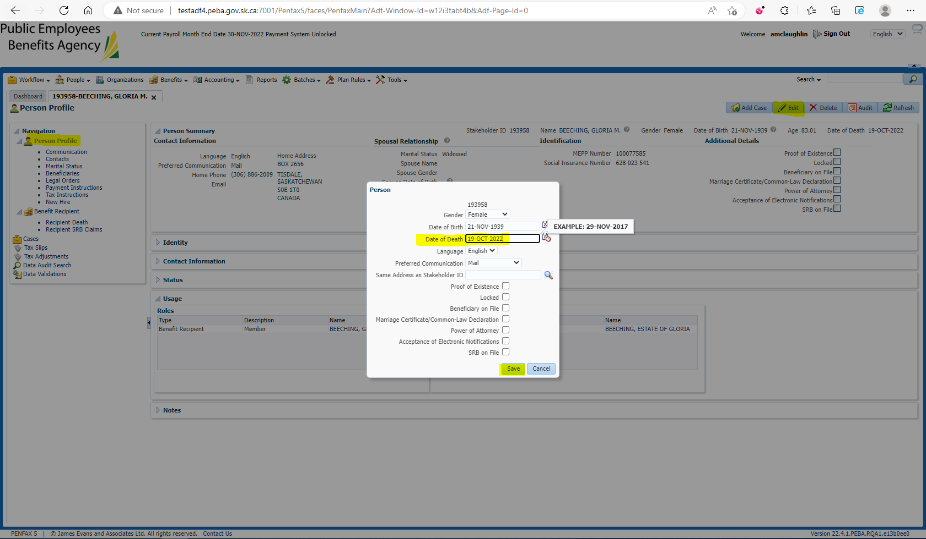

Open the Death Calc 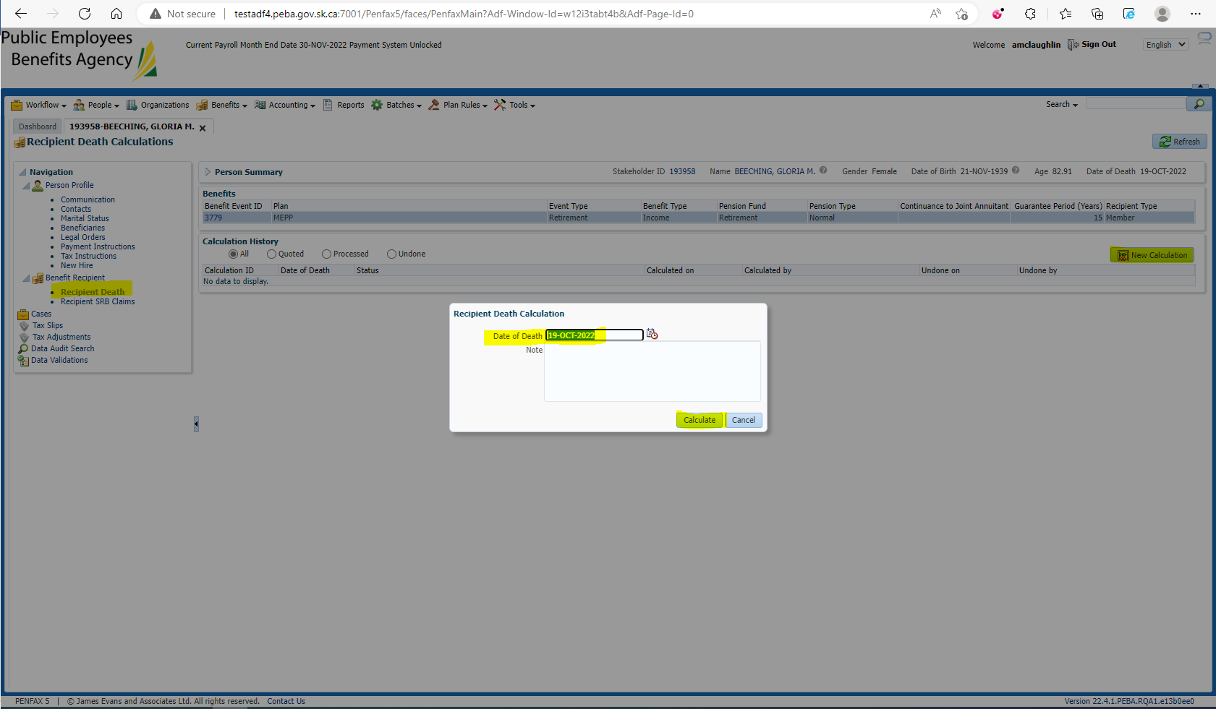

Verify there is no benefit payable in the Death Calculation, Process 2x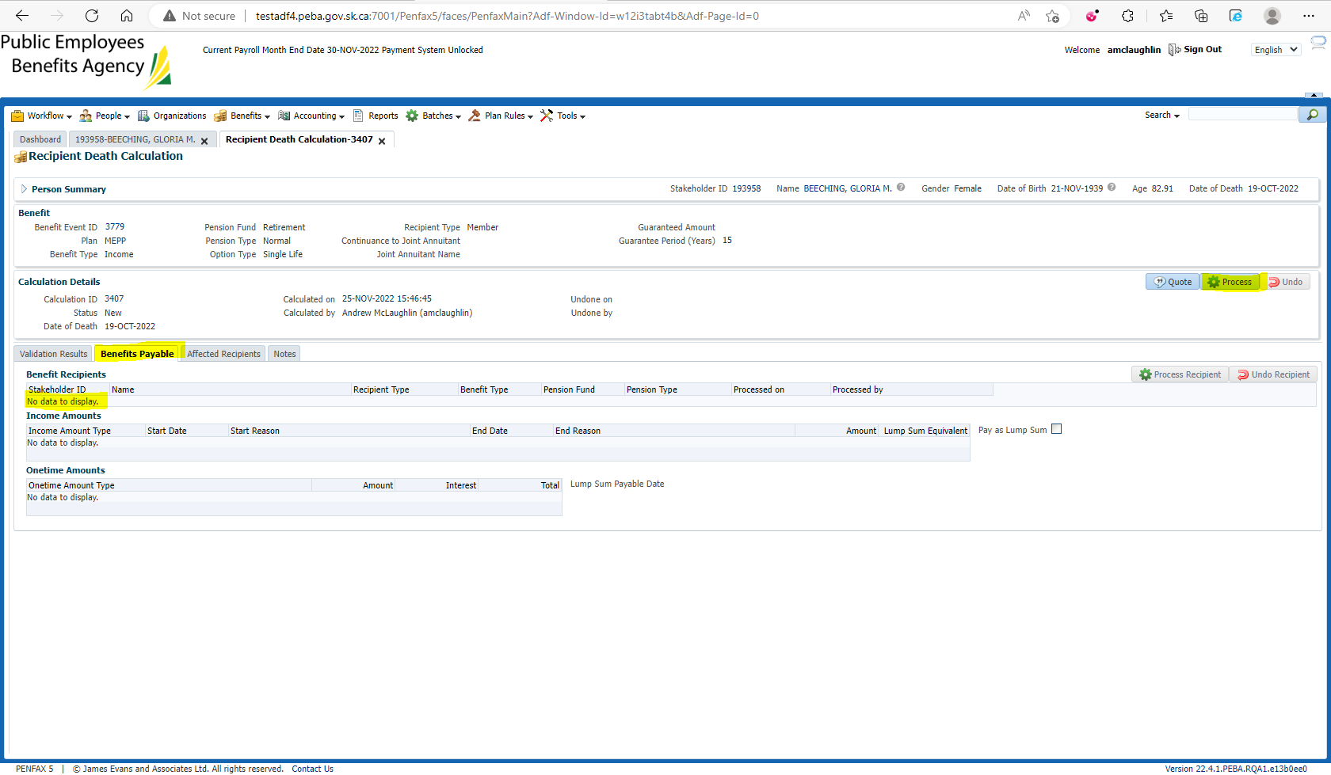

Verify under the member’s Income Benefit that all benefits end at the end of the month of death 